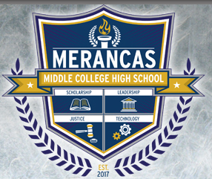

Merancas Middle College High School

Testing Reminder
PSAT
October 11, 2017

This is just a reminder that your child will be taking the Preliminary SAT (PSAT) on Wednesday, October 11th at 8:00 am. The PSAT is given at no cost to all 11th grade students in Charlotte-Mecklenburg Schools. It is our goal that all juniors attend and test, regardless of prior testing exposure to the PSAT.

The test consists of critical reading, mathematics, and writing sections, and has the same formats, directions, sample questions, and question types as the Scholastic Assessment Test (SAT), which many students take as a college entrance examination. The PSAT provides excellent preparation for taking the SAT; in addition, schools use the results to aid instructional and program planning.

Please make every effort to have your child at school and on time the day of testing, so that we may begin promptly in the morning. It is better to encourage your child to be relaxed, rather than to encourage additional drill or extra study at the last minute. For testing, your child will need to bring to school two wood-barreled No. 2 pencils and a calculator with which he/she is comfortable. Please do not bring mechanical pencils. Also, NO ELECTRONIC DEVICES ARE PERMITTED. Students found to be in possession of electronic devices, including cell phones, during testing will be excused and their tests will not be scored.

October 11th is a regularly scheduled school day. We will dismiss at 4:15 pm. As usual, lunch will be served during testing days, once testing has concluded.

If you have any questions, please contact Tonya Morris, Test Coordinator.

Thank you for your support!

